
Ohio State University Extension

Miami County Extension Office

510 W Water St.
Ste 250, 2nd Floor
Troy, OH 45373

937-440-3945 Phone

miami.osu.edu

September 27, 2021

Dear Potential 4-H Camp Counselor:

Thank you for your interest in becoming a volunteer counselor for our 2022 Miami County 4-H camping season.
Volunteering as a camp counselor provides you with an opportunity to gain new skills, help others, and meet new friends.
Working with campers can bring you great satisfaction as you help them grow, learn, develop, and succeed.

What’s included in the application packet:

• Camp Counselor Application • Camp Counselor Standards of Behavior • Counselor Code of Conduct

• 2 Counselor Reference Forms (completed by non-family members for first-time applicants only)

Additional details: Application Deadline – October 29, 2021

- Camp Information: The 2022 Miami County 4-H Jr. Camp will be held June 5-9 (Sunday – Thursday) at Indian Hills 4-H Camp located in Pleasant Hill. The Cloverbud Day Camp date and location are to be determined.

- Counselor Age Eligibility: Applicants must be ages 14-18 as of January 1, 2022.

- Selection Process: New and returning applicants must submit a completed application packet and participate in an individual interview. First time applicants must also provide two reference forms. Please return the completed application packet by Friday, October 29, 2021, to OSU Extension, Miami County, 510 W Water St, Ste 250, Troy, OH 45373. Interviews will be held virtually for 15 minutes and by appointment only. Interviews will be held on Thursday, November 4, 6:00 p.m. – 8:30 p.m., Monday, November 8, 6:00 p.m. – 8:30 p.m., and Wednesday, November 10, 6:00 p.m. – 8:00 p.m. All applicants will be contacted to schedule an individual interview.

If you have any questions, please contact Amanda Bennett at bennett.709@osu.edu or 937-440-3945. We look forward to working with you.

Sincerely,

Amanda Bennett and Alisha Barton
Extension Educators

OHIO STATE UNIVERSITY EXTENSION
4-H EVENT/OPPORTUNITY: 4-H Camp Counselor

DATE / DEADLINE: Applications are due to the OSU Extension Office no later than October 29, 2021 by 4:00 p.m.
PROGRAM DESCRIPTION:
4-H Cloverbud Day Camp Counselors are a group of teens selected to assist in being responsible for campers ages 5 and Kindergarten through second grade during 4-H camp. 4-H Jr. Camp Counselors are a group of teens selected to assist in being responsible for campers ages 8 and in third grade (or 9 regardless of grade level) through age 13 during 4-H camp. As a result of participation, counselors will develop knowledge, skills, attitudes and aspirations needed for adult success, and the Miami county 4-H program will be strengthened and expanded. Roles and Responsibilities of 4-H Camp Counselors include:

- Attend required trainings prior to camp
- Market and promote camp
- Serve in a leadership and teaching role to other counselors
- Serve on committees or other groups to plan programs at camp
- Conduct self in an appropriate manner before, during, and after camp while serving as a role model to campers and peers
- Assist staff and other counselors with camp activities; work as a team to implement the activities
- Know and understand all safety guidelines, including emergency procedures, associated with the camp and program areas
- Follow and enforce camp rules
- Assure for safety of campers at all times including in cabins, sessions, and large group activities
- Be aware of child protection regulations and report any child abuse, sexual abuse, or neglect in accordance with university policy
- Identify and respond to camper behavior issues
- Ensure campers’ health and hygiene, e.g., brushing teeth, eating meals, taking medication, etc.
- Promote camper participation during camp
- Lead and supervise campers in activities at camp including but not limited to songs, teambuilding challenges, group activities, challenges, etc.
- Teach and lead campers at workshops or during other components at camp (table setting, song leading, etc.)
- Mentor and give guidance to campers to encourage positive youth development and enhancement of life skills

REQUIREMENTS:
- Must be at least 14 years old by January 1, 2022.
- Must be able to get transportation to meetings and events as needed.
- Must complete a minimum of 24 hours of training. (2 of these hours must be on-sight for first time counselors).
- Must complete Child Abuse Awareness training.
- Must Sign Standards of Behaviors, complete the Code of Conduct form, and have a current Ohio 4-H Health History form on file.
- First time applicants must provide two references.
- If the individual is 18+ year old at least two months prior to camp, the individual must have their background check conducted.

SELECTION PROCESS:
- Individuals who complete the application and fulfill application requirements will be contacted regarding the selection process.

MEETING DATES/TIME/FREQUENCY
4-H Camp Counselors meet the following dates throughout the year: December 2021 – June 2022.
Counselors are expected to notify the Extension Office if an absence is unavoidable.

TO APPLY:
- Complete the application in its entirety.
- Turn in reference forms from two non-family members (first time applicants only).
- Read and sign the Standards of Behavior and Camp Counselor Code of Conduct forms.
- Return all materials to OSU Extension Miami, 510 W Water St., Ste 250,, Troy, OH 45373 by Friday, October 29.
4-H CAMP COUNSELOR APPLICATION
OHIO STATE UNIVERSITY EXTENSION

Name _____________________________________________________________________________

Age (January 1, 2022) _____________ Date of Birth ________________ (00/00/0000)
Home Address _______________________________________________________________________
(Street) (City) (State) (Zip)

Email ________________________________ Home Phone _______________________________

Cell Phone ____________________________ Is texting an option? (circle) Yes No

In case of injury or accident, notify:

Name __________________________ Relationship __________________ Phone ______________

Why do you want to be a camp counselor? ___________________________________________________
_____________________________________________________________________________________
__________________________________________________________________________________________________________________________________________________________________________

What traits, skills, or special experiences do you have that would benefit you in this position? (Please include experiences working with children and youth.) __________________________________________
_____________________________________________________________________________________
__________________________________________________________________________________________________________________________________________________________________________

What skills or contributions will you add to the counselor team in making sure camp is successful? (such as First Aid, Babysitter’s Course, Recreation, etc.) _______________________________________________
_____________________________________________________________________________________
__________________________________________________________________________________________________________________________________________________________________________

What hobbies and/or special interests do you have that you would like to share? _____________________
_____________________________________________________________________________________
__________________________________________________________________________________________________________________________________________________________________________

Please list 2 of your strengths. _____________________________________________________________
_____________________________________________________________________________________
__________________________________________________________________________________________________________________________________________________________________________

Are you currently a 4-H member? Have you attended 4-H camp?

Have you ever been a 4-H camp counselor? If yes, how many years?

Is this your final year of eligibility as a counselor? T-Shirt Size:

Please circle which camp(s) you would like to work with: Jr. Camp and/or Cloverbud Day Camp.
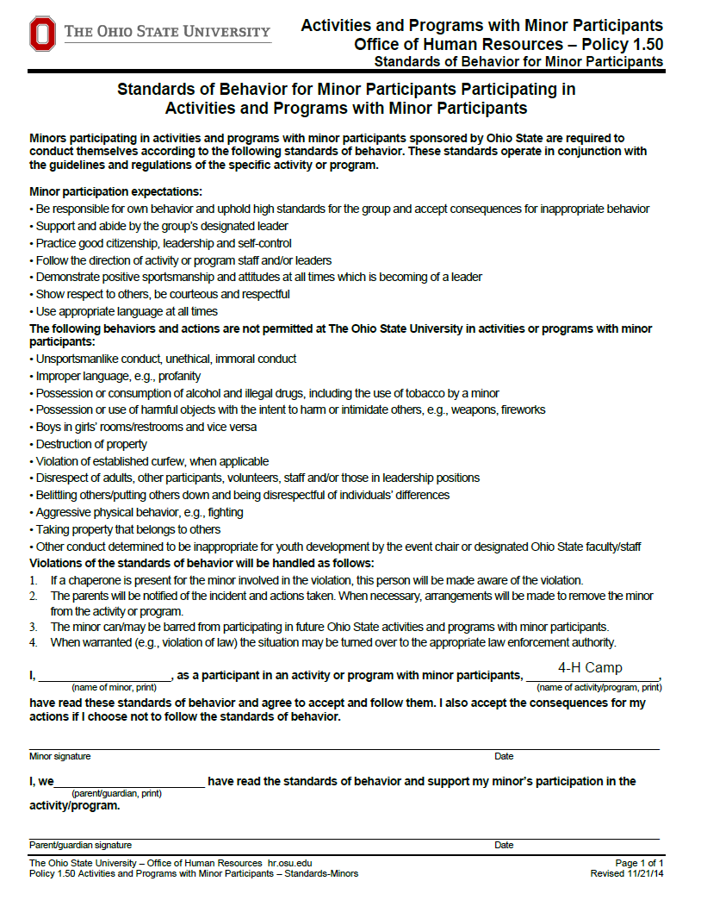
4-H CAMP COUNSELOR CODE OF CONDUCT
OHIO STATE UNIVERSITY EXTENSION

I, ______________________ agree that if selected, I will participate in the 4-H Camp Counselor Training Program. I understand that this is a training period and only once I complete my certification am I permitted to be a counselor at 4-H Camp.

I understand that I am taking on a different role at camp. I am applying to serve others, not to go purely for my own enjoyment. By signing below, I acknowledge that I have read and agree to abide by the above responsibilities if selected as a camp counselor. I understand and agree that I will be asked to call my parents/guardian immediately to pick me up if I conduct myself in an irresponsible manner, which includes being out of my cabin after hours and/or the possession or use of tobacco, alcohol, illegal drugs or fireworks.

I will be expected to:
- Attend the required number of counselor training sessions. I understand I will be dismissed if I am not able to complete the required training.
- Abide by the No Cell Phones at Camp Policy (note: unless otherwise authorized by Extension staff)
- Treat other peers with respect.
- Not bully fellow counselors or participate in roughhousing, horse-play, or hazing.
- Conduct myself as a positive role model and be responsible.
- Set a good example by not using profanity or telling off-color jokes, and stories.
- As a 4-H member/youth volunteer, not have in my possession tobacco, alcohol or illegal drugs.
- Not have possession of harmful objects without specific authorization from the camp director, including but not limited to: knives of any kind (pocket, utility, etc.), lighters, matches, fireworks, explosives, firearms, weapons, etc.
- No pornography or other sexually oriented materials including nudity in visual or written materials including similar content.
- Be a responsible cabin counselor and ensure campers are provided guidance towards a safe and fun week.
- Ensure that all campers are supervised by counselor staff at all times. Be sure that all campers know that they must remain on the camp grounds at all times and are responsible for their behavior at all times.
  - Get to know each of the campers personally and by name.
  - Have all campers, including myself check in any of their medications with the nurse.
  - Make sure each camper uses personal hygiene.
  - Make sure that all of my campers are familiar with camp facilities and camp rules.
  - See that all campers are involved in all activities. Make sure no one is excluded.
- Check for illness or injury, but don't make much of a "fuss" about minor things. Go with hurt or sick campers to the nurse no matter how minor the ailment.
- Follow guidelines for lights out, and cabin supervision. Be in my cabin with my campers at all times between the hours of "Lights Out" and "Rise and Shine.”
- Never discipline a camper by ridicule or physical punishment; patience and understanding works best.
- Urge safety at all time. Take time to explain how and why to do something safely.
- Work as a team to plan, organize and conduct all camp activities.
- Be flexible with counseling and adult staff.
- Participate in camp promotion.
- Follow leadership of camping program through adult advisors/volunteers/staff.

I certify that the all the information being submitted is correct, and understand that failure to comply with these rules could result in probation, or loss of counseling position for the year.

Applicant’s Signature _________________________________ Date ____/_____/_____
Parent/ Guardian Signature ______________________________ Date ____/_____/_____
REFERENCE FORM
OHIO STATE UNIVERSITY EXTENSION

___________________ is applying as a camp counselor at 4-H Camp this summer. The camp counselor selection committee would like your input about the qualities and ability to fulfill the responsibilities of a counselor. The information you include will not be shared with the applicant. Please complete this reference form based on your knowledge and/or observations. Thank you for your help.

- Please mark how you would evaluate the applicant’s qualities, using this scale:
 | Excellent | Good | Fair | Poor | Not Known
Responsibility
Communication skills
Respect for others
Dependability
Enthusiasm
Flexibility
Patience
Initiative
Resourcefulness
Ability to work with children (age 5-10)
Ability to work with children
(ages 11-14)
Ability to work with other teens
Ability to work with adults

- Please write any additional comments here:

Signed: __________________________________________ Date: __________________
Printed Name: _____________________________________
Relationship to Applicant: _________________________________________
Address: ______________________________________________________________________________
Email: _________________________________________ Phone: ________________________________

Please return no later than October 29, 2021.
Address: OSU Extension, Miami County, 510 W St, Ste 250., Troy, OH 45373
E-mail: bennett.709@osu.edu

Please note: Please submit in a sealed envelope or to bennett.709@osu.edu. For questions, contact the OSU Extension Office.
REFERENCE FORM
OHIO STATE UNIVERSITY EXTENSION

___________________ is applying as a camp counselor at 4-H Camp this summer. The camp counselor selection committee would like your input about the qualities and ability to fulfill the responsibilities of a counselor. The information you include will not be shared with the applicant. Please complete this reference form based on your knowledge and/or observations. Thank you for your help.

- Please mark how you would evaluate the applicant’s qualities, using this scale:
 | Excellent | Good | Fair | Poor | Not Known
Responsibility
Communication skills
Respect for others
Dependability
Enthusiasm
Flexibility
Patience
Initiative
Resourcefulness
Ability to work with children (age 5-10)
Ability to work with children
(ages 11-14)
Ability to work with other teens
Ability to work with adults

- Please write any additional comments here:

Signed: __________________________________________ Date: __________________
Printed Name: _____________________________________
Relationship to Applicant: _________________________________________
Address: ______________________________________________________________________________
Email: _________________________________________ Phone: ________________________________

Please return no later than October 29, 2021.
Address: OSU Extension, Miami County, 510 W St, Ste 250., Troy, OH 45373
E-mail: bennett.709@osu.edu

Please note: Please submit in a sealed envelope or to bennett.709@osu.edu. For questions, contact the OSU Extension Office.

